Vitafit factory tour image - 3o6bj7l10acpesk13pdlk02a25 l
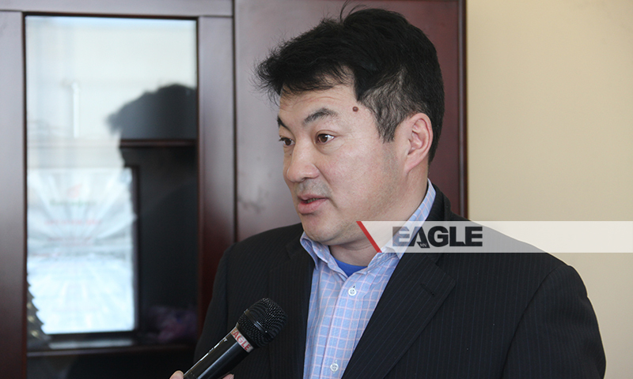

identifier
00c7d2b1-a876-4d91-83f9-fff6445e7a01

creator

type
Image

coverage
Mongolia

description
Goyo yogurt factory tour image published by Eagle.mn.

publisher

source

rights

subject
Mongolia
dairy
nationalism
social media

date
2014

language
Vitafit factory tour image - Vitafit factory tour image - 3o6bj7l10acpesk13pdlk02a25 l

format
image/jpeg

original filename
3o6bj7l10acpesk13pdlk02a25_l.jpg

extent
262.0 KiB
800x480 px

modified
2014-03-24 18:28:54

