Photographs of Dashbalbar sum, No. 40
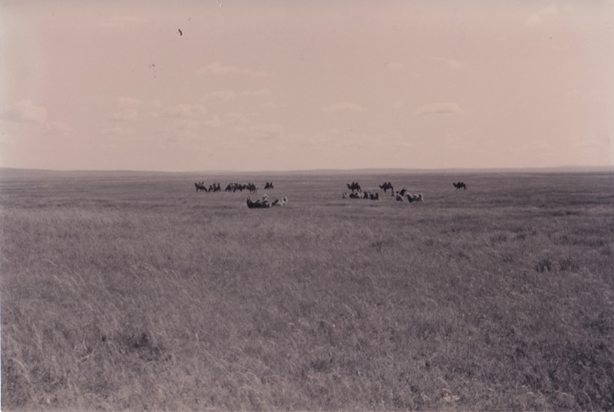

identifier
00cb3d8c-7c8a-48f8-ae63-c08c8e235b88

creator
Batbuyan B.

type
Image

coverage
Dashbalbar sum
Dornod aimag
Mongolia

description
Sebsuul region, Dashbalbar

publisher

source
Scanned from a photographic print held in the archives of the Mongolia and Inner Asia Studies Unit, University of Cambridge.

rights

subject
camels
rangeland

date
1993-09

language

format
image/png

contributor

original filename
bair-batbuyan-photos-40.png

relation

extent
1760x1182 px
2.7 MiB

