MacArthur project staff
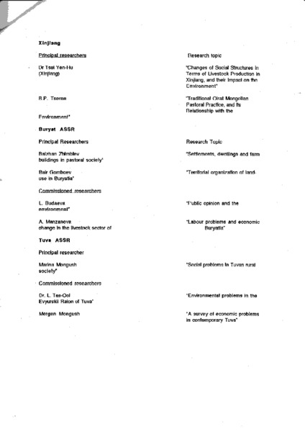

identifier
03f3ac74-1c43-489c-b851-21b98244f9bc

creator
Sneath, David

type
Text

coverage

description
List of staff/team members of the Cambridge MacArthur project “Environmental & Cultural Conservation in Inner Asia”

publisher

source
Scanned from an original document held in the archives of the Mongolia and Inner Asia Studies Unit, University of Cambridge.

rights

subject
research planning

date
ca. 1992

language
English

original filename
macarthur-project-staff.pdf

relation

extent
164.1 KiB

contributor

format
application/pdf

modified
2017-05-25 18:50:37

