Where is East Asia? Central Asian and Inner Asian Perspectives on Regionalism
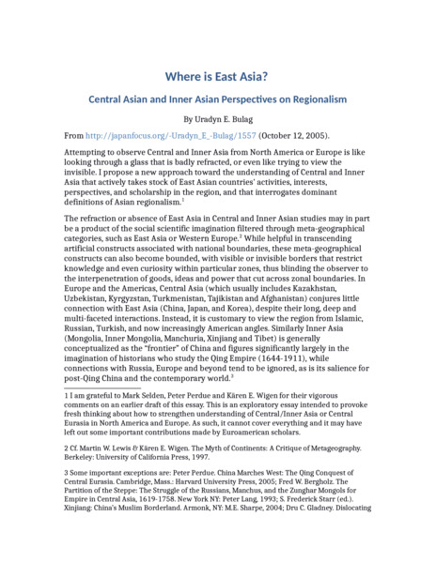

identifier
0485769d-13ba-4486-ade7-09c84f6c7aba

creator
Uradyn E Bulag

type
Text

coverage
Inner Asia

description
“Attempting to observe Central and Inner Asia from North America or Europe is like looking through a glass that is badly refracted, or even like trying to view the invisible. I propose a new approach toward the understanding of Central and Inner Asia that actively takes stock of East Asian countries' activities, interests, perspectives, and scholarship in the region, and that interrogates dominant definitions of Asian regionalism.”

publisher
The Asia-Pacific Journal

source
<http://japanfocus.org/-Uradyn_E_-Bulag/1557>
The Asia-Pacific Journal: Japan Focus. October 12, 2005. Volume 3, Issue 10.

rights
Copyright Uradyn E Bulag

subject
Inner Asia
Regionalism

date
2005

language
English

original filename
Bulag2005.docx

extent
22.9 KiB

format
application/vnd.openxmlformats-officedocument.wordprocessingml.document

modified
2018-01-03 23:30:33

