The Mongols of Manchuria
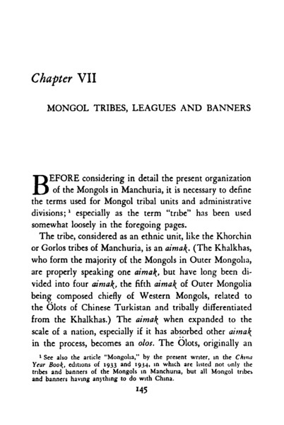

identifier
051b02d8-fa84-49a2-8d42-e46f0e0e97b0

creator
Lattimore, Owen

type
Text

coverage
Manchuria
China

description
Full title: The Mongols of Manchuria: Their tribal divisions, geographical distribution, historical relations with Manchus and Chinese, and present political problems. This book presents material derived from Lattimore’s travel and observations in Manchuria, Peiping, and Inner Mongolia (1929-1933); textual research; and interviews with Mongolian and Chinese informants. Lattimore notes in his Introduction that, given the context of colonization in Manchuria (the Japanese colony of Manchukuo had been established in 1931-1932), he wishes to present colonization “from the Mongol point of view”, which has not previously been widely discussed.

publisher
George Allen & Unwin Ltd.

source

rights

subject
Manchuria
colonization

date
1935

language
English

contributor

original filename
The-Mongols-Of-Manchuria.pdf

relation

extent
15.8 MiB

format
application/pdf

modified
2017-05-29 12:12:48

remote embed url
https://archive.org/stream/in.ernet.dli.2015.79995?ui=embed

public

