Activities at Delger Farm, Sainshand, Dornogovi
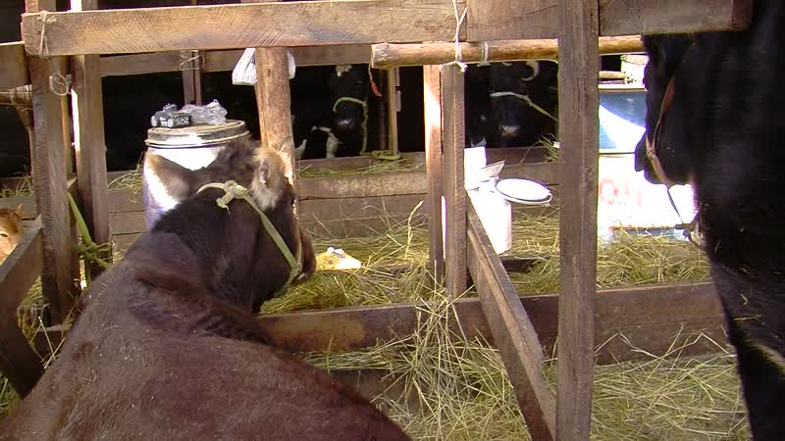

identifier
06a3138a-c98b-4097-ab68-68772ea6d1cf

creator
Thrift, Eric

type
Moving Image

coverage
Mongolia
Dornogovi aimag
Sainshand sum

description
This series of audiovisual recordings documents the feeding and milking of cattle at Delger Farm, located approximately 20 km to the south of Sainshand. The cows are milked three times a day throughout the year, producing approximately 80 litres of milk per day at the time of our visit. The cattle are managed by a couple who are employed by the Delger Farm Cooperative, and who are relatives of the manager (Delgersaikhan).

publisher

source

rights

subject
Pastoralism Videos
Delger Farm
Milking Cattle

date
2012-03-12

language

remote embed url
https://archive.org/embed/06a3138a-c98b-4097-ab68-68772ea6d1cf

format
inode/directory

modified
2018-01-17 20:15:05

original filename
PastoralismVideos--2012-03-12--DelgerFarm--MilkingCattle--Dornogovi-Sainshand.vclips

table of contents
time | clip | description
0:00:00 | 244 0178 01
0:13:54 | 244 0178 02
0:27:48 | 244 0178 03
0:41:42 | 244 0178 04
0:55:36 | 244 0178 05
1:09:31 | 244 0178 06
1:23:25 | 244 0178 07
1:37:19 | 244 0178 08
1:49:49 | 244 0179 01
2:00:08 | 244 0179 02
2:14:02 | 244 0179 03

