Photographs of Dashbalbar sum, No. 24
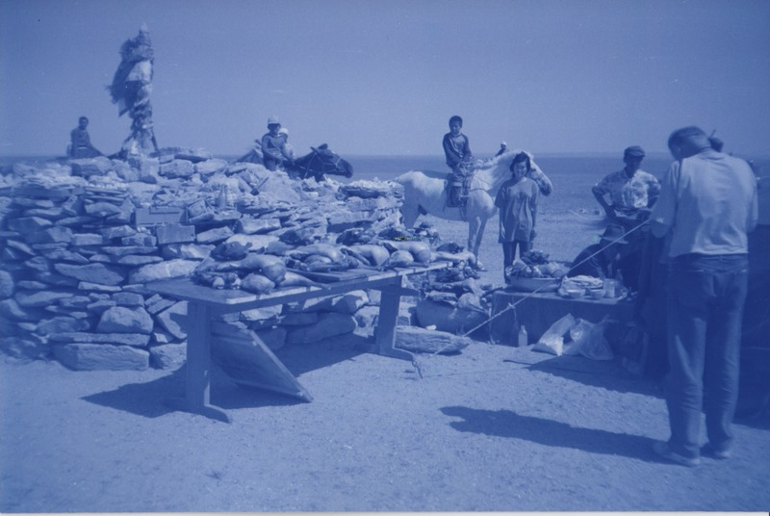

identifier
07636625-6e13-456d-a543-2dfcc3039525

creator
Batbuyan B.

type
Image

coverage
Dashbalbar sum
Dornod aimag
Mongolia

description
Ovoo worship in Dashbalbar.

publisher

source
Scanned from a photographic print held in the archives of the Mongolia and Inner Asia Studies Unit, University of Cambridge.

rights

subject
ovoo

date
1993

language

format
image/png

contributor

original filename
bair-batbuyan-photos-24.png

relation

extent
1777x1191 px
3.0 MiB

