Labour tasks
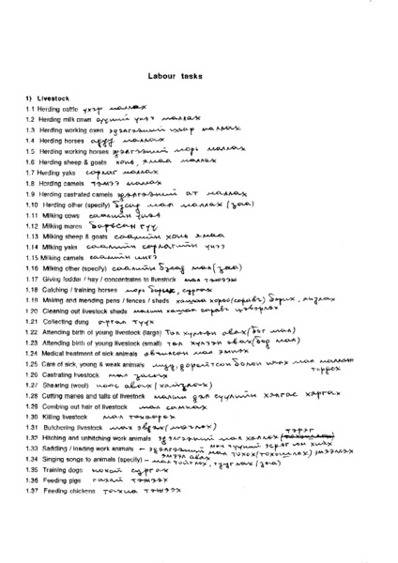

identifier
0ed38af0-92fe-4be6-bd02-5fd6580fb5c6

creator
Sneath, David

type
Text

coverage
Inner Asia

description
List of tasks and activities involved in Inner Asian mobile pastoralism. This list was prepared in order to focus participant observation on the microeconomics of pastoralism, as reflected in everyday labour practices.

publisher

source
Scanned from an original document held in the archives of the Mongolia and Inner Asia Studies Unit, University of Cambridge.

rights

subject
research planning
mobile pastoralism
everyday life

date
ca. 1992

language
English

original filename
macarthur-labour-tasks.pdf

relation

extent
2.0 MiB

contributor

format
application/pdf

modified
2017-05-29 12:12:49

