9405
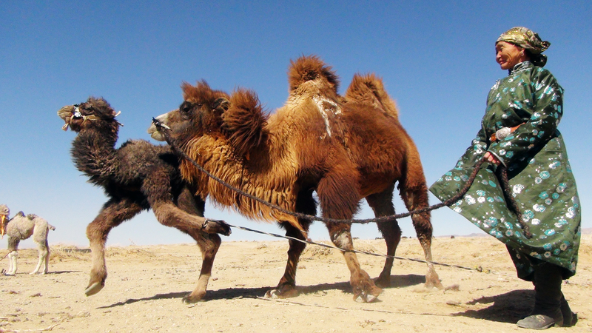

identifier
0f9bb4cb-d75e-4c47-9926-c3ae0d247eac

creator
Boldbaatar, Yu.

type
Image

coverage
Mongolia
Ömnögovi aimag
Mandal-Ovoo sum

description
Preparing for the coaxing ritual for baby camels - 3 (Mandal Ovoo soum, Umnugovi province)

publisher

source
https://ich.unesco.org/img/photo/src/09405.jpg

rights

subject

date
2013

language

original filename
09405.jpg

extent
9.5 MiB
6016x3384 px

format
image/jpeg

modified
2016-02-24 14:46:09

