Photograph from Govisumber, No. 01
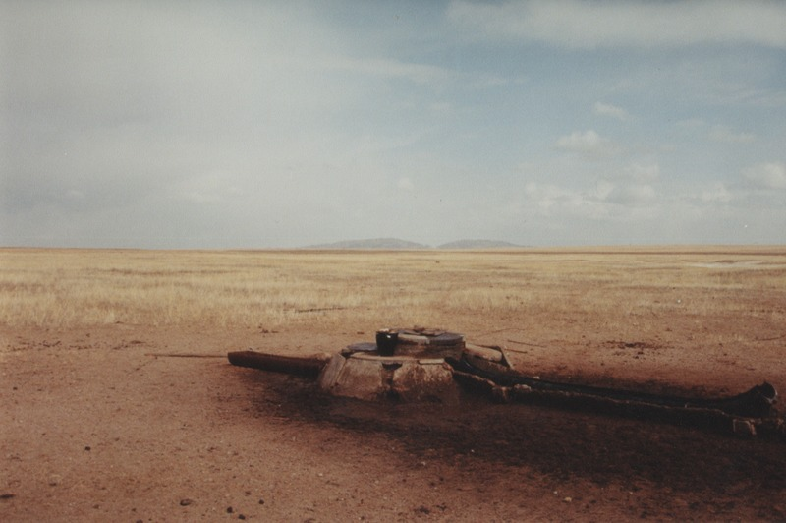

identifier
10c190b2-1fe0-4bf4-bb91-b1dceabe9cd8

creator
Sneath, David

type
Image

coverage
Govisumber aimag
Mongolia

description

publisher

source
scanned from a photographic print held in the archives of the Mongolia and Inner Asia Studies Unit, University of Cambridge

rights

subject
wells

date
1995

language

format
image/png

contributor

original filename
sneath-govisumber_01.png

relation

extent
1776x1182 px
3.1MiB

