Figure from the essay "The Power of Two Homelands" by R. Plueckhahn
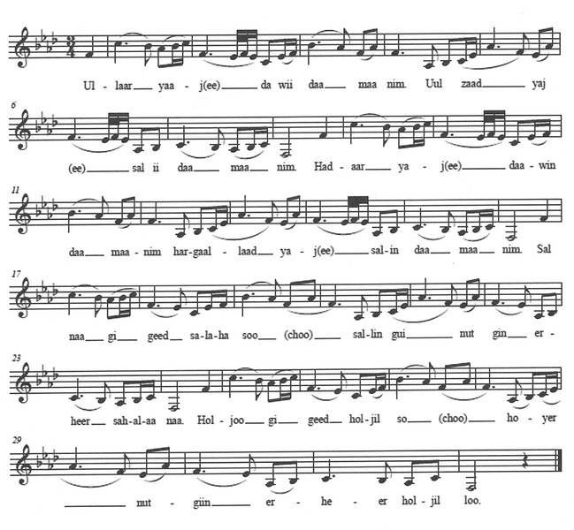

identifier
123cba8f-3694-427b-a53d-8ceb1eb13596

creator
Plueckhahn, Rebekah

type
Image

coverage
Mongolia

description

publisher

source

rights

subject
ethnomosicology
Altain Uriankhai

date
2017-05-23 12:28:42

language

original filename
Plueckhahn2013-fig-1.png

extent
390.6 KiB
1000x925 px

format
image/png

modified
2017-05-29 12:00:27

