9404
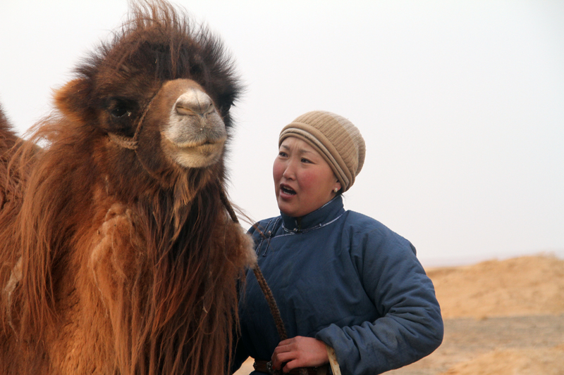

identifier
1454593c-7915-4aa9-b867-8d1cbef765b1

creator
Boldbaatar, Yu.

type
Image

coverage
Mongolia
Ömnögovi aimag
Mandal-Ovoo sum

description
Using the melody of Morin Khuur for coaxing the mare-camel and orphan calf -1 (Mandal Ovoo soum, Umnugovi Province)

publisher

source
https://ich.unesco.org/img/photo/src/09404.jpg

rights

subject

date
2013

language

original filename
09404.jpg

extent
8.2 MiB
5184x3456 px

format
image/jpeg

modified
2016-02-24 14:45:56

