Vitafit factory tour image - 764f91uerpfkja0q06d5vrb4a0 l
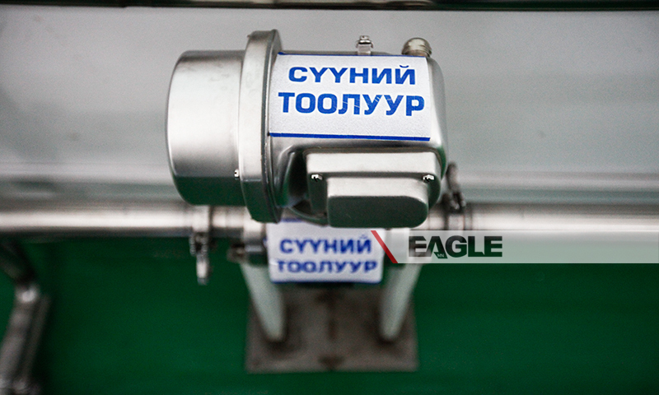

identifier
147229b7-5ef1-4e9b-96e3-543e5be75d70

creator

type
Image

coverage
Mongolia

description
Goyo yogurt factory tour image published by Eagle.mn.

publisher

source

rights

subject
Mongolia
dairy
nationalism
social media

date
2014

language
Vitafit factory tour image - Vitafit factory tour image - 764f91uerpfkja0q06d5vrb4a0 l

format
image/jpeg

original filename
764f91uerpfkja0q06d5vrb4a0_l.jpg

extent
308.7 KiB
800x480 px

modified
2014-03-24 18:28:56

