”Оргил хүнс”-ийнхэн ”Гоё” таргаа хятад таргаар савладаг
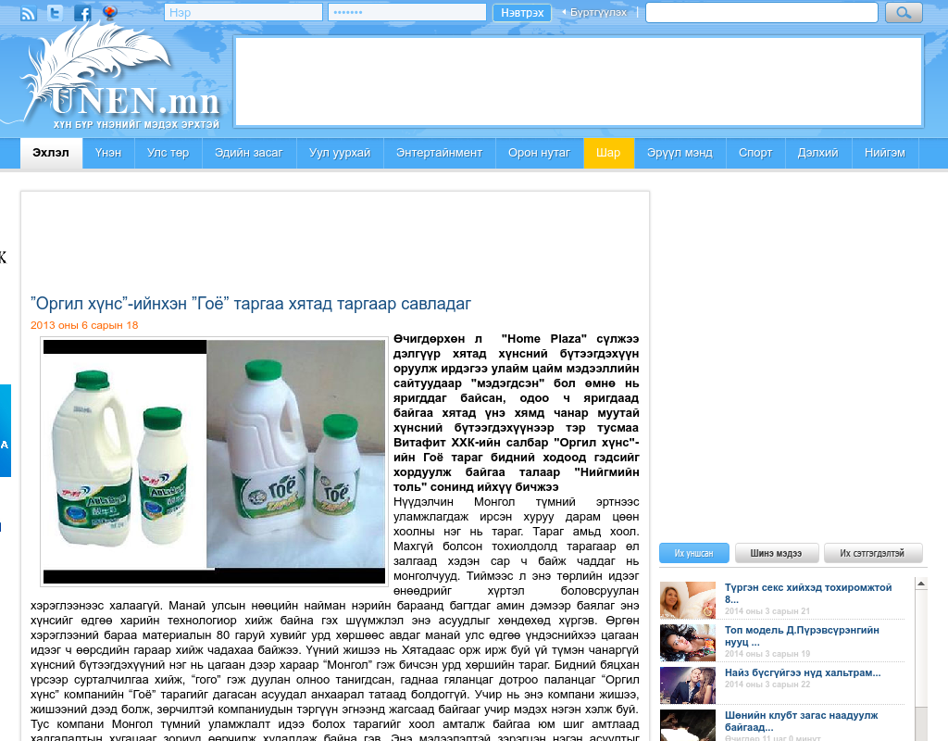

identifier
172b971a-cb87-4850-845d-788b96c5c1d6

creator

type
Text

coverage
Mongolia

description

publisher

source
http://www.unen.mn/content/24135.shtml

rights

subject
Mongolia
dairy
nationalism
social media

date
25 Mar 2014 10:57:04

language
Mongolian

format
text/plain

modified
2018-01-11 14:12:43

original filename
unen.mn.Khyatad_targaar_savladag.url

extent
38.0 B

