Letter by Caroline Humphrey, 1992-05-22
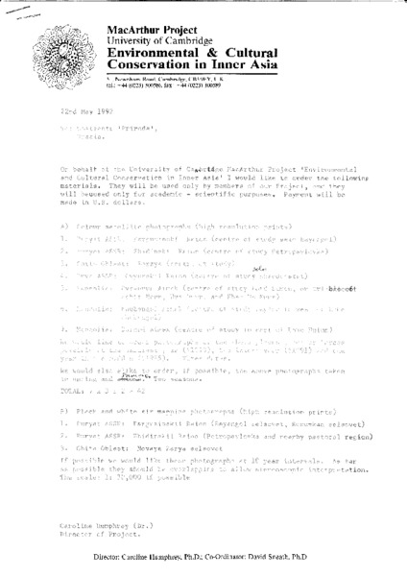

identifier
173b8295-be25-441c-98cb-f975051b401d

creator
Humphrey, Caroline

type
Text

coverage

description

publisher

source
Scanned from an original document held in the archives of the Mongolia and Inner Asia Studies Unit, University of Cambridge.

rights

subject

date
ca. 1992

language

original filename
humphrey-letter-priroda-1992-05-22.pdf

relation

extent
235.8 KiB

contributor

format
application/pdf

modified
2017-05-25 10:47:20

