Шинэ Зеландын “Хортой” сүүний талаарх мэдээлэл
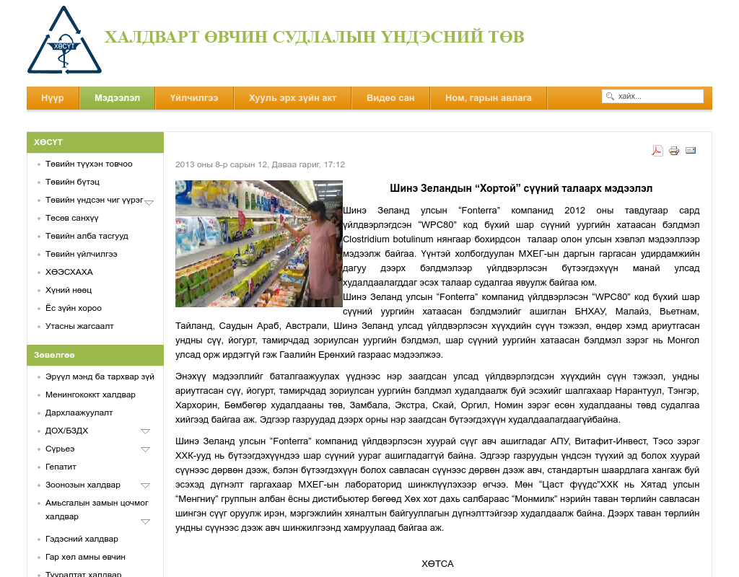

identifier
17b26f11-35dd-48a5-abc1-1f5ba0005a7b

creator

type
Text

coverage
Mongolia

description

publisher

source
http://www.nccd.gov.mn/index.php?option=com_content&amp;view=article&amp;id=353:2013-08-12-08-30-01&amp;catid=21:2011-09-01-03-24-23&amp;Itemid=42

rights

subject
Mongolia
dairy
nationalism
social media

date
9 Jun 2014 20:56:54

language
Mongolian

format
text/plain

modified
2018-01-11 14:12:43

original filename
nccd.gov.mn.Khortoi_suu.url

extent
146.0 B

