Map of the Gobi Desert
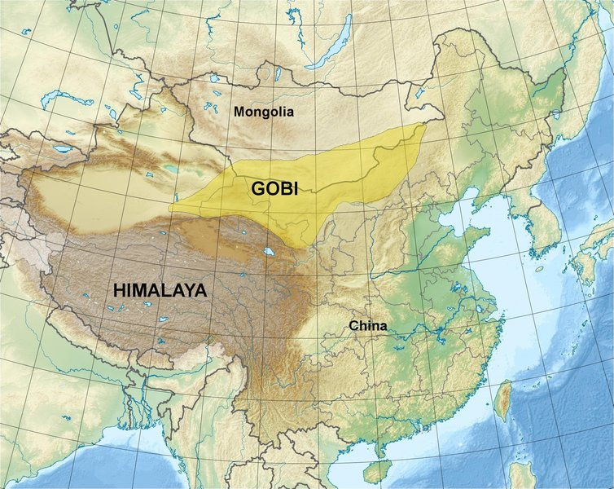

identifier
180bb423-89b6-4deb-9f97-ddc4b537d8b9

creator
Cagé, Christophe

type
Image

coverage
Gobi
Mongolia
PRC

description
Map showing China, Mongolia, the Himalayas, and the Gobi region

publisher
Wikimedia Commons

source
<https://commons.wikimedia.org/wiki/File:Gobi_desert_en.jpg>

rights
This file is licensed under the Creative Commons Attribution-Share Alike 3.0 Unported license.

subject
Gobi
maps

date
2011

language
English

original filename
Gobi_desert_en.jpg

extent
655.4 KiB
1968x1567 px

format
image/jpeg

modified
2017-10-08 11:55:24

