9406
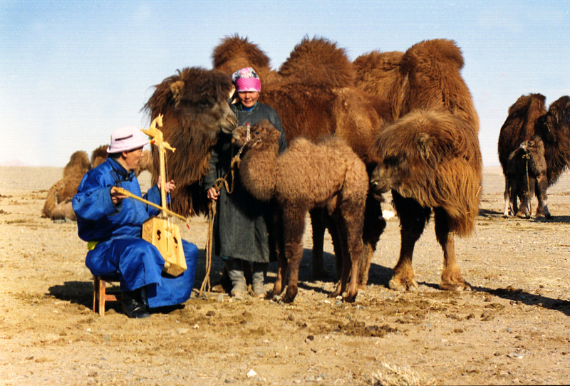

identifier
1c01571d-2f84-4158-89fc-66165d8c4ecf

creator
Boldbaatar, Yu.

type
Image

coverage
Mongolia
Ömnögovi aimag
Khankhongor sum

description
The mare-camel is accepting the orphan calf - 1 (Khankhongor Sooum, Umnugobi Province)

publisher

source
https://ich.unesco.org/img/photo/src/09406.jpg

rights

subject

date
2011

language

original filename
09406.jpg

extent
2.8 MiB
2655x1800 px

format
image/jpeg

modified
2016-02-24 14:45:44

