1941904. Batyr Elistaev, About Buddhist Holidays
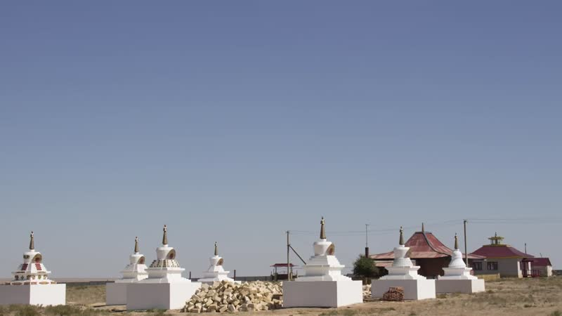

identifier
1c8ebd1b-c92c-48f2-872a-a8392244b59d

creator
Kalmyk Cultural Heritage Documentation Project

type
Moving Image

coverage
Kalmykia
Russia

description

publisher
University of Cambridge

source
<http://www.kalmykheritage.socanth.cam.ac.uk>

rights
Copyright Kalmyk Cultural Heritage Documentation Project. Licensed under a Creative Commons BY-NC-ND Unported license.

subject
Buddhism
Kalmyks

date
2015-06-15 13:26:35

language

extent
143.2 MiB
383.720000

format
video/mp4

modified
2017-05-27 10:45:44

original filename
1941913.mp4

remote embed url
http://sms.cam.ac.uk/media/1941904/embed

public
FALSE

