Photograph from Govisumber, No. 22
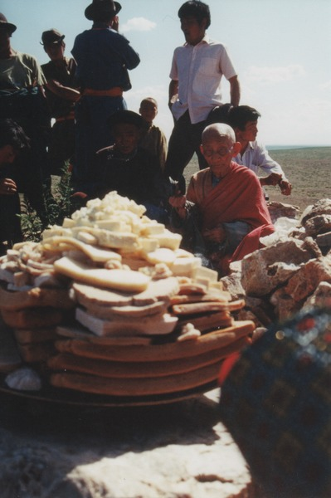

identifier
1cb588f7-3fc4-493f-8ea2-8cb172311ffb

creator
Sneath, David

type
Image

coverage
Govisumber aimag
Mongolia

description

publisher

source
scanned from a photographic print held in the archives of the Mongolia and Inner Asia Studies Unit, University of Cambridge

rights

subject
Buddhist monk
offerings (ideenii tavag)
ovoo

date
1995

language

format
image/png

contributor

original filename
sneath-govisumber_22.png

relation

extent
1182x1776 px
3.2MiB

