Чанарын шаардлага хангахгүй “Гоё” таргийг дахин үйлдвэрлэхгүй байхыг шаардлаа
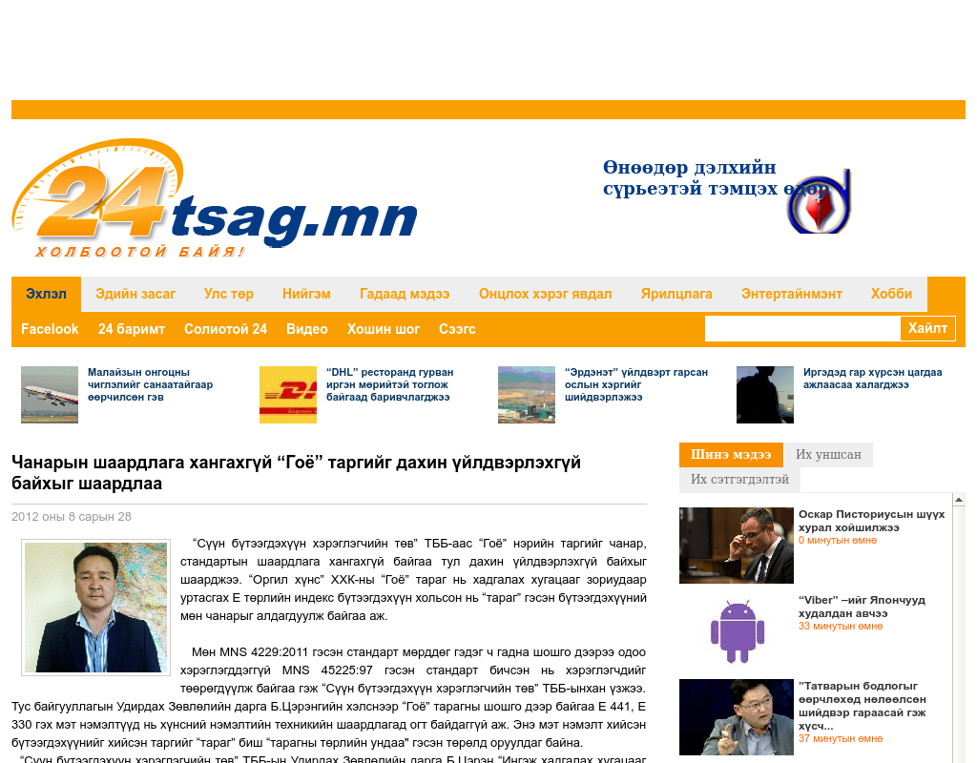

identifier
1d1ce649-bddd-434b-8c76-75922f1f2665

creator

type
Text

coverage
Mongolia

description

publisher

source
http://www.24tsag.mn/content/17389.shtml

rights

subject
Mongolia
dairy
nationalism
social media

date
24 Mar 2014 14:38:10

language
Mongolian

format
text/plain

modified
2018-01-11 14:12:43

original filename
24tsag.mn.Chanaryn_shaardlaga_khangakhgui.url

extent
40.0 B

