Olloo.mn - Єдєр бvр дэлхий даяар - “Гоё” тараг Монгол уу, Хятад уу
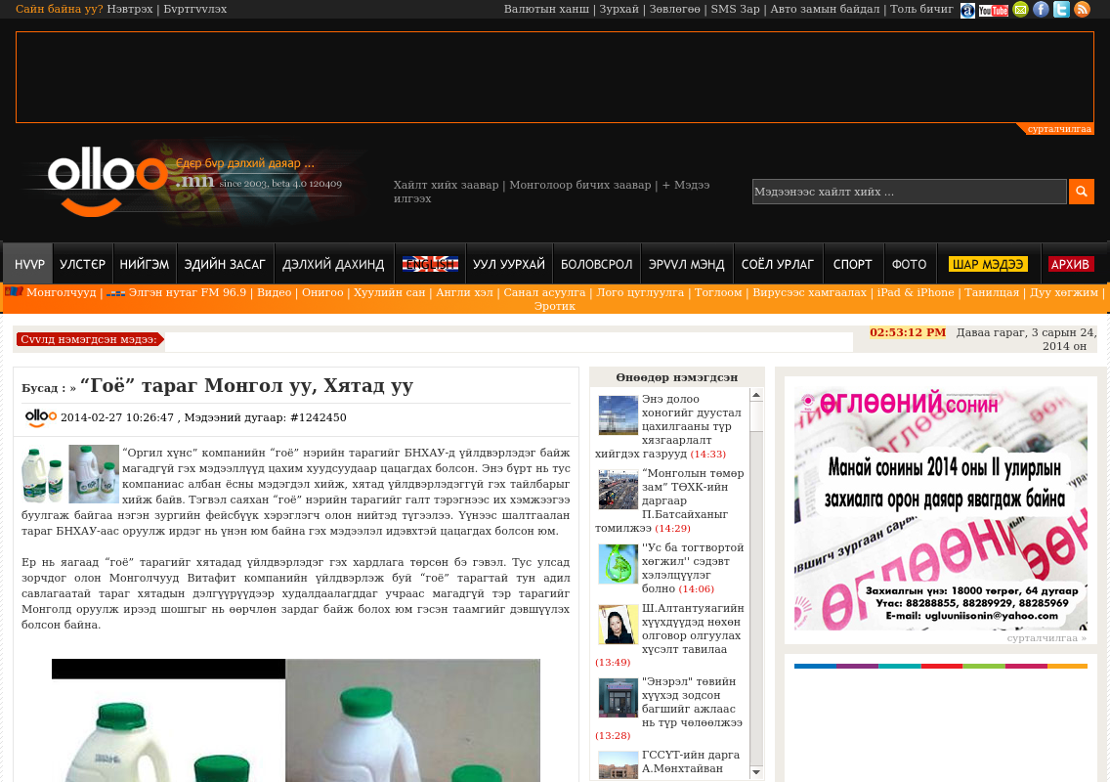

identifier
1d83dceb-a389-4acc-8c42-6c28b1aa16a0

creator

type
Text

coverage
Mongolia

description

publisher

source
http://www.olloo.mn/News/1242450.html

rights

subject
Mongolia
dairy
nationalism
social media

date
24 Mar 2014 14:53:03

language
Mongolian

format
text/plain

modified
2018-01-11 14:12:43

original filename
olloo.mn.Mongol_uu_Khyatad_uu.url

extent
37.0 B

