Caroline Humphrey Mongolia Super8 film no. 9
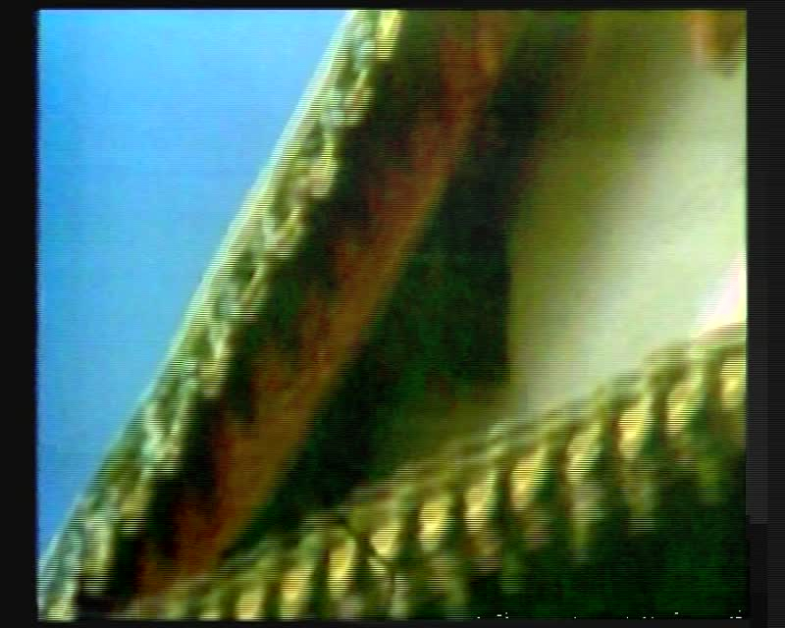

identifier
1ef62304-14b7-42a4-b78c-202822bcfe22

creator
Humphrey, Caroline

type
Moving Image

coverage
Erdene-Zuu Monastery
Mongolia

description
Exterior of Erdene-Zuu Monastery

publisher
MIASU

source
Digitized from a VCR transfer tape held at the Mongolia and Inner Asia Studies Unit, University of Cambridge

rights
Copyright Caroline Humphrey

subject
monasteries

date
ca. 1970s

language
None

original filename
humphrey-super8-mongolia-09.mp4

extent
1.1 GiB
218.304000

format
video/mp4

modified
2017-06-16 10:19:56

alternate url
https://archive.org/embed/1ef62304-14b7-42a4-b78c-202822bcfe22

