Photograph from Inner Mongolia, No. 20
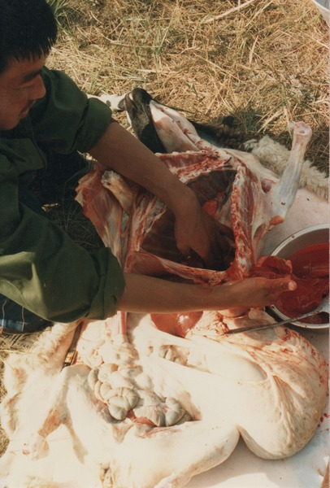

identifier
1f861703-74af-4733-bd11-c1558b2b05ab

creator
Sneath, David

type
Image

coverage
Inner Mongolia
PRC

description
Slaughtering a sheep.

publisher

source
Scanned from a photographic print held in the archives of the Mongolia and Inner Asia Studies Unit, University of Cambridge.

rights

subject
sheep slaughter

date
ca. 1988

language

original filename
sneath-inner-mongolia-1980s.png_20.png

relation

extent
3.3 MiB
1182x1747 px

contributor

format
image/png

modified
2017-05-25 11:11:50

