Photographs from Barguzin, No. 11
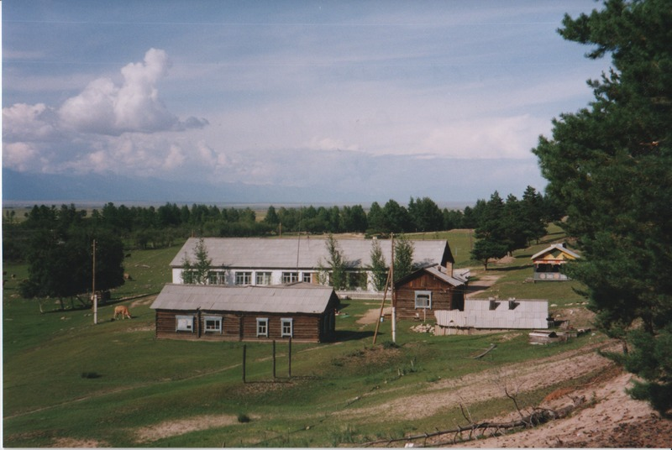

identifier
209bfa1c-848a-4c54-9066-9108f5a78e9b

creator
Gomboev, Bair

type
Image

coverage
Barguzin
Burtyatia
Russian Federation

description
The health resort “Arshan” (i.e., sacred spring), near Bayangol, Barguzin.

date
1993-07

language

format
image/png

modified
2017-05-25 02:06:02

original filename
bair-batbuyan-photos-11.png

source
Scanned from a photographic print held in the archives of the Mongolia and Inner Asia Studies Unit, University of Cambridge

extent
3.2 MiB
1777x1191 px

subject
health resorts
sacred springs

