MASS.mn - Түрүүлж мэдээлнэ
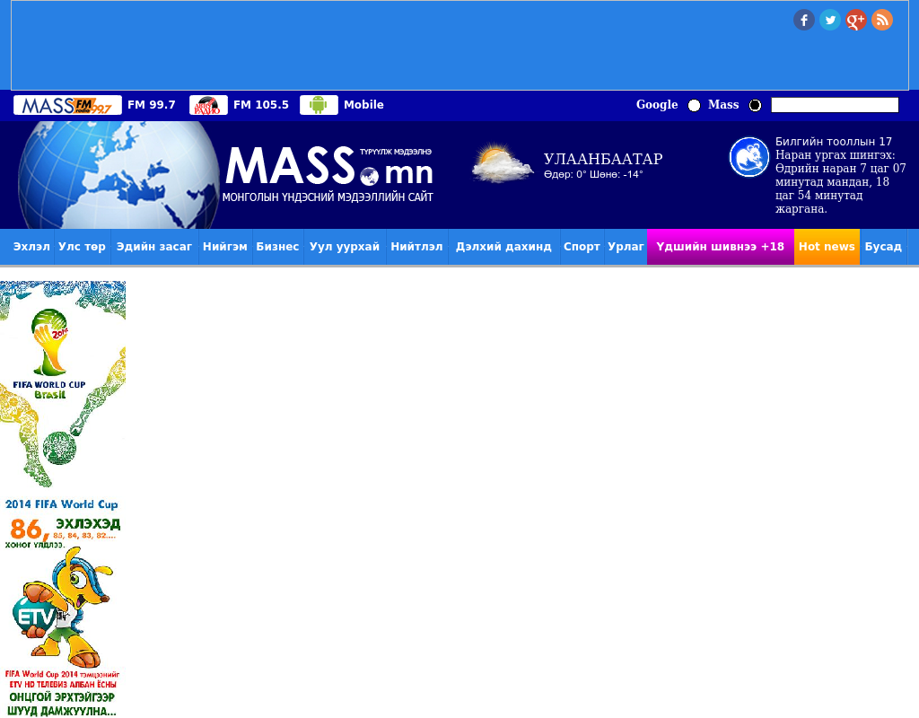

identifier
20c27071-ee9d-4478-8359-be32f31717ad

creator

type
Text

coverage
Mongolia

description

publisher

source
http://www.mass.mn/109492.html

rights

subject
Mongolia
dairy
nationalism
social media

date
18 Mar 2014 12:13:52

language
Mongolian

format
text/plain

modified
2018-01-11 14:12:43

original filename
mass.mn.Goyo_targiig_khaana_uildverledgiig.url

extent
30.0 B

