Caroline Humphrey - Buryatia photos - No. 2-12
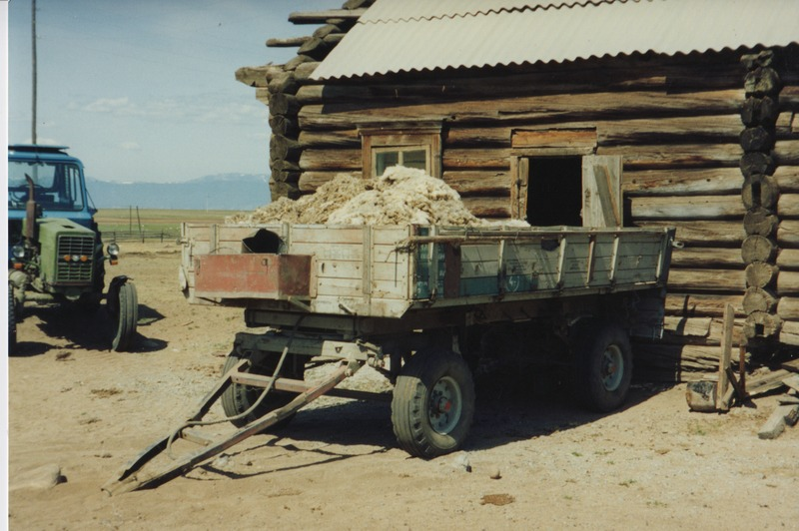

identifier
210dd7eb-4662-4ba5-8811-9e21b4f68627

creator
Humphrey, Caroline

type
Image

coverage
Bayangol
Khilgana
Karl Marx Collective
Buryatia
USSR

description
Wool from shorn sheep.

publisher

source
Scanned from a print held in the archives of the Mongolia and Inner Asia Studies Unit, University of Cambridge.

rights

subject

date
1993

language

contributor

original filename
Humphrey-Buryatia-photos-2-12.png

relation

extent
3.4MiB
1799x1196 px

format
image/png

