David Sneath - photographs from Xingmeng, Yunnan - No. 17
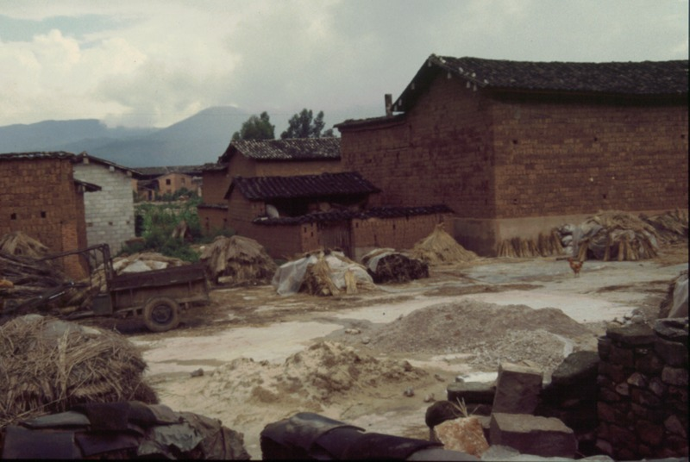

identifier
21dcc9e5-7fee-4bec-a300-0754528ca701

creator
Sneath, David

type
Image

coverage
PRC
Yunnan

description

publisher

source
Digitized from a 35mm slide provided by the author.

rights

subject

date
1997

language

format
image/tiff

contributor

original filename
David Sneath - photographs from Xingmeng, Yunnan - No. 17.tif

relation

extent
42.6MiB
4704x3168 px

public

