David Sneath - photographs from Xingmeng, Yunnan - No. 26
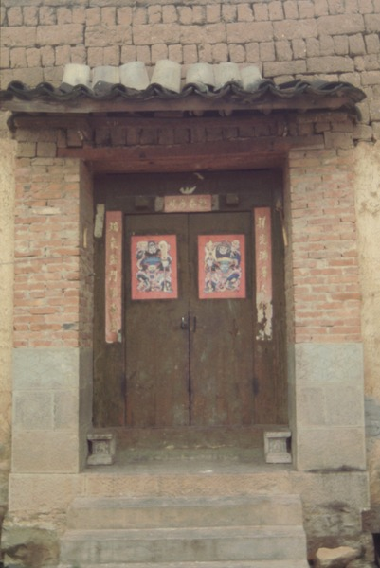

identifier
245a032c-5fa7-4ec3-b94c-2693790f961c

creator
Sneath, David

type
Image

coverage
PRC
Yunnan

description

publisher

source
Digitized from a 35mm slide provided by the author.

rights

subject

date
1997

language

format
image/tiff

contributor

original filename
David Sneath - photographs from Xingmeng, Yunnan - No. 26.tif

relation

extent
42.6MiB
4704x3168 px

public

