Completed ethnographic interview questionnaire from the Cambridge MacArthur project on a “knowledgeable old person” (redacted)
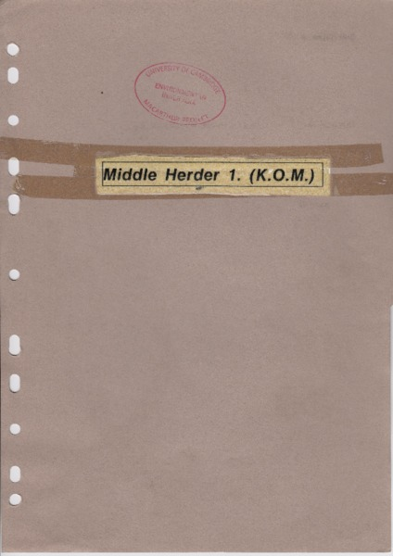

identifier
27b76d57-ebcc-425b-8b50-0b5ed412d528

creator

type
Text

coverage

description

publisher

source
Scanned from an original document held in the archives of the Mongolia and Inner Asia Studies Unit, University of Cambridge.

rights

subject

date
ca. 1992

language

original filename
macarthur-interview-questionnaire-KOP-redacted.pdf

relation

extent
75.7 MiB

contributor

format
application/pdf

modified
2017-05-26 03:09:58

