6130
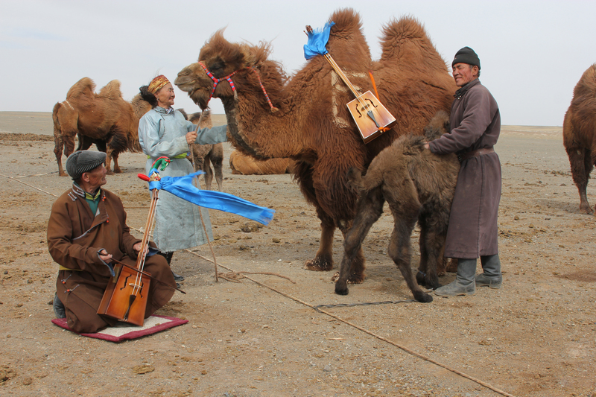

identifier
29658c82-373e-4462-a9b6-7709cb6eeb50

creator
Boldbaatar, Yu.

type
Image

coverage
Mongolia
Ömnögovi aimag
Khankhongor sum

description
Using the melody of Morin Khuur for coaxing the mare-camel and orphan calf (Khankhongor Sooum, Umnugobi Province)

publisher

source
https://ich.unesco.org/img/photo/src/6130.jpg

rights

subject

date
2011

language

original filename
06130.jpg

extent
9.3 MiB
4500x3000 px

format
image/jpeg

modified
2012-12-05 02:28:25

