Oral history interview No. 091028A with Batmönh (b. 1978): translation
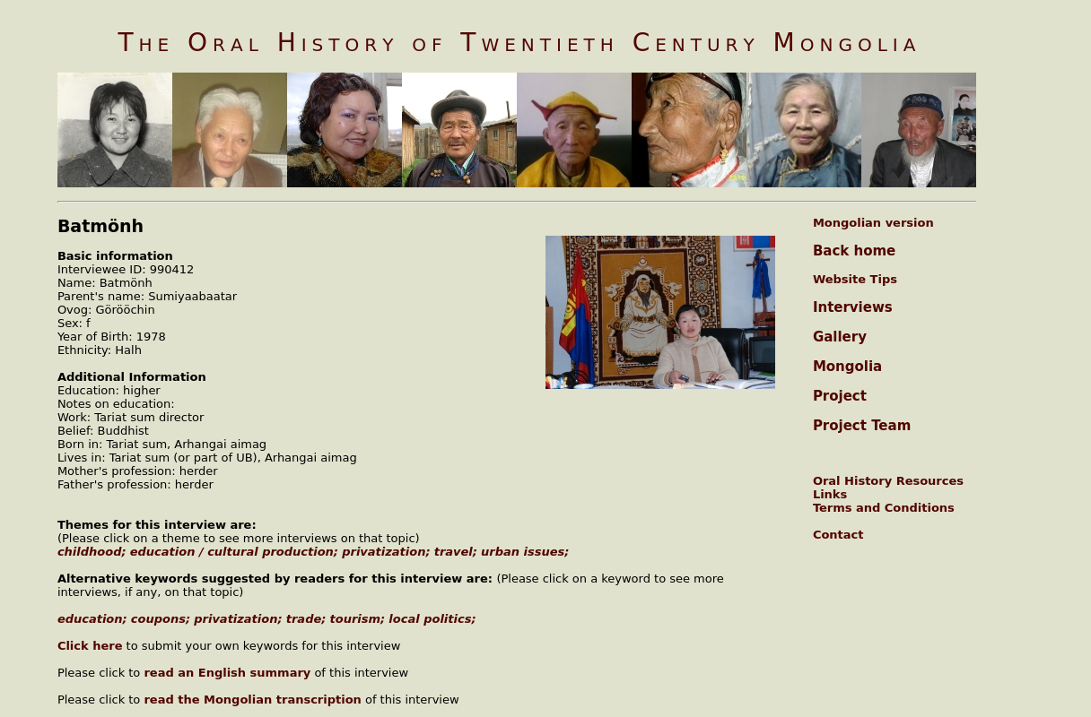

identifier
2ec9c1c8-be46-4f37-922f-5f7c884759ad

creator
Batmönh

type
Text

coverage
Arkhangai aimag
Mongolia

description
Oral history interview with Sumiyaabaatar Batmönh.

publisher
Oral History of Twentieth Century Mongolia

source
<http://amantuuh.socanth.cam.ac.uk/search/view_trans.php?Interview=091028A>

rights
Copyright MIASU. Reproduced with permission. Brief excerpts from interviews and other material may be used in academic or popular work for non-commercial purposes provided proper attribution and credit is given to the Oral History of Twentieth Century Mongolia and the Mongolia and Inner Asia Studies Unit (MIASU). You must not: (a) republish this material (including republication on another website) without the express written permission of MIASU; (b) sell, rent or sub-license material from the website; (c) show any material from the website in public without attribution to The Oral History of Twentieth Century Mongolia; (d) reproduce, duplicate, copy or otherwise exploit material on the website for a commercial purpose without express written permission; (e) use the material in any way that is damaging to the project or any of the persons named in the interviews. See <http://amantuuh.socanth.cam.ac.uk/terms.php> for details.

subject
childhood
education
oral history
privatization
travel
urban issues

date
2009

language
English

format
text/plain

contributor
Buyandelger

original filename
091028A-Batmönh-translation.url

relation
aa7a4cbf-17b0-4911-b918-26e5245be71a

extent
74.0 B

