Tracking degradation from space
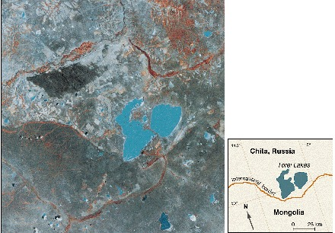

identifier
303b5dd2-fc09-4390-a9b8-9b450d0f82be

creator
Sneath, David

type
Image

coverage
Inner Asia

description
Satellite image (Landsat, October 1989) of the border between the Russian district of Chita and northeastern Mongolia. Lakes are blue, areas with the most vegetation are red, greens and grays indicate intermediate amounts of vegetation, and pale and white areas are sandy and bare earth. In the northern (Russian) half of the image, the land is lighter in color, scarred, and marked where the thin topsoil has been exposed or covered with drifting sand. In the southern (Mongolian) half of the image, the vegetation cover is much more uniform. (Inset) A map is given for comparison.

publisher
Science

source
DOI: 10.1126/science.281.5380.1147
Sneath, David. “State Policy and Pasture Degradation in Inner Asia”. Science 21 Aug 1998: Vol. 281, Issue 5380, pp. 1147-1148.

rights
© 1998 American Association for the Advancement of Science

subject
GIS
Inner Asia
rangeland ecology

date
1998

language
English

format
image/gif

modified
2017-10-08 12:06:32

extent
94.8 KiB
440x306 px

