Stratified sampling plan
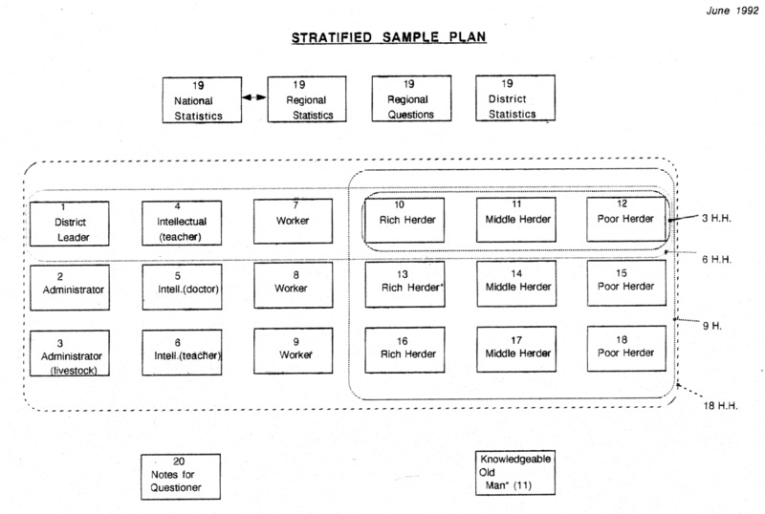

identifier
3605ed78-0de7-40c4-95f2-445e5aa3d0ce

creator
Sneath, David

type
Image

coverage

description
Stratified sampling plan for the Cambridge MacArthur project 鈥淓nvironmental & Cultural Conservation in Inner Asia鈥� Each interviewer was assigned to work with two people or households representing each of nine sampling categories in their field site, over a six month period.

publisher

source
Scanned from an original document held in the archives of the Mongolia and Inner Asia Studies Unit, University of Cambridge.

rights

subject
research planning
sampling

date
ca. 1992

language
English

original filename
macarthur-stratified-sample-plan.png

relation

extent
1.4 MiB
3114x2095 px

contributor

format
image/png

modified
2017-05-25 10:53:00

