Caroline Humphrey - Buryatia photos - No. 20
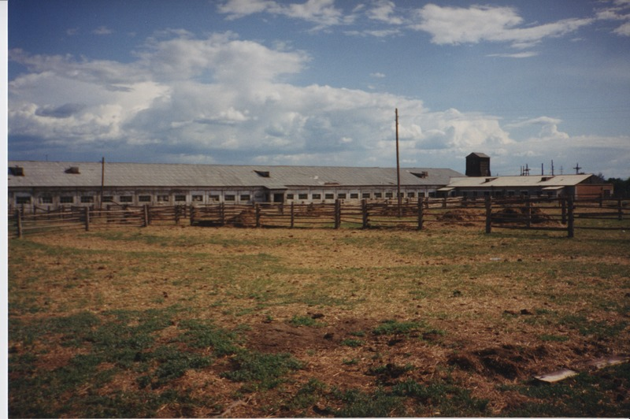

identifier
365acd92-5c94-4da0-98ce-8d1cf3b935ce

creator
Humphrey, Caroline

type
Image

coverage
Ulung Collective
Buryatia
USSR

description
Cattle overwintering shed (also used for winter milking).

publisher

source
Scanned from a print held in the archives of the Mongolia and Inner Asia Studies Unit, University of Cambridge.

rights

subject

date
1993-07-25

language

contributor

original filename
Humphrey-Buryatia-photos-20.png

relation

extent
3.3MiB
1799x1196 px

format
image/png

