Oral history interview No. 090745B with Garamhand (b. 1934): translation
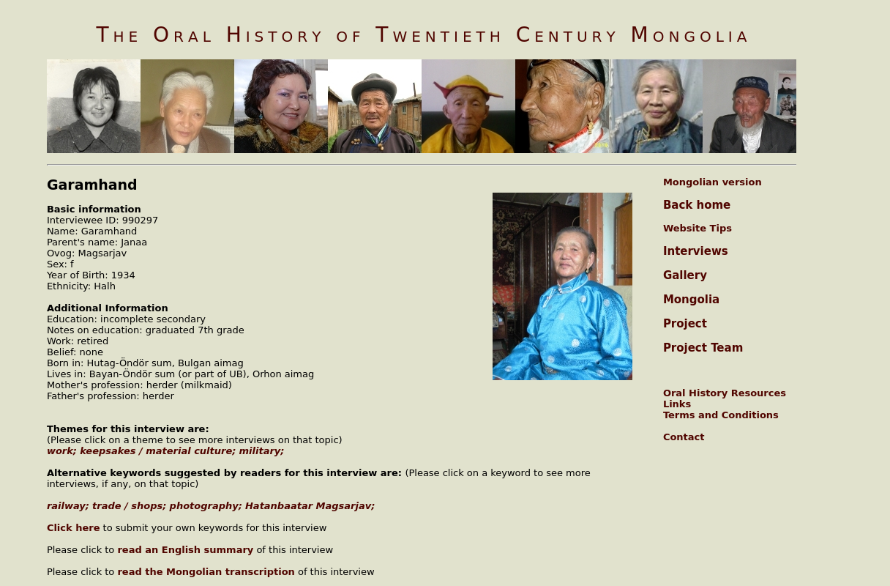

identifier
366619c0-75c7-443a-9e4f-a9bf13a5cd3c

creator
Garamhand

type
Text

coverage
Mongolia
Orkhon aimag

description
In the second part of her interview J. Garamhand told about the people who worked at the trade organizations. In the socialist period they occasionally had the problem of being in debt. Although the people had cash, there was a lack of consumer goods to buy. The provisioning of goods was poor. She worked at the railway and there the provision of goods was sufficient when compared to other places. Her husband did Party leadership work, worked as a school director, state farm darga, and a superintendent in the construction trust and railway. At the end of her interview she showed various historical photos.

publisher
Oral History of Twentieth Century Mongolia

source
<http://amantuuh.socanth.cam.ac.uk/search/view_trans.php?Interview=090745B>

rights
Copyright MIASU. Reproduced with permission. Brief excerpts from interviews and other material may be used in academic or popular work for non-commercial purposes provided proper attribution and credit is given to the Oral History of Twentieth Century Mongolia and the Mongolia and Inner Asia Studies Unit (MIASU). You must not: (a) republish this material (including republication on another website) without the express written permission of MIASU; (b) sell, rent or sub-license material from the website; (c) show any material from the website in public without attribution to The Oral History of Twentieth Century Mongolia; (d) reproduce, duplicate, copy or otherwise exploit material on the website for a commercial purpose without express written permission; (e) use the material in any way that is damaging to the project or any of the persons named in the interviews. See <http://amantuuh.socanth.cam.ac.uk/terms.php> for details.

subject
Khatanbaatar Magsarjav
keepsakes
military
oral history
railway
trade
work

date
2009

language
English

format
text/plain

contributor
Khishigsüren

original filename
090745B-Garamhand-translation.url

relation
f3a8b748-757c-422b-9c0b-2a4e315f6016

extent
74.0 B

