Caroline Humphrey Mongolia Super8 film no. 13
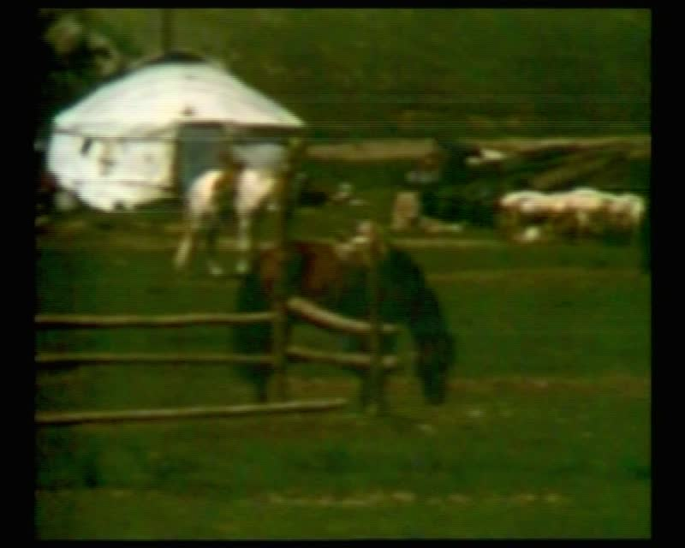

identifier
37c24678-1556-49cd-8975-e2e1e4d420f7

creator
Humphrey, Caroline

type
Moving Image

coverage
Mongolia

description
Party wife; herders' camp; people on horses; horse-line

publisher
MIASU

source
Digitized from a VCR transfer tape held at the Mongolia and Inner Asia Studies Unit, University of Cambridge

rights
Copyright Caroline Humphrey

subject
pastoral camps
riding horses

date
ca. 1970s

language
None

original filename
humphrey-super8-mongolia-13.mp4

extent
876.3 MiB
217.110000

format
video/mp4

modified
2017-06-16 11:51:07

alternate url
https://archive.org/embed/37c24678-1556-49cd-8975-e2e1e4d420f7

