MacArthur project research hypotheses
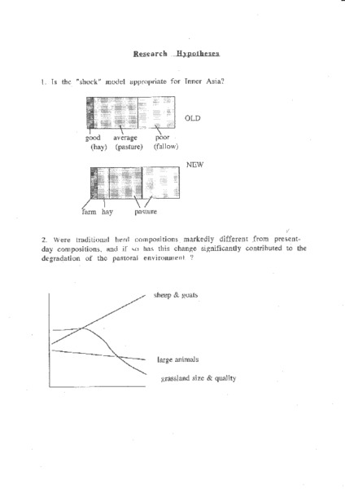

identifier
38721ec9-673b-4a29-9644-3040f1158c8a

creator
Sneath, David

type
Text

coverage
Inner Asia

description
Early working document listing a set of research questions (hypotheses) related to culture and the environment in Inner Asia of the early 1990s, followed by a set of draft questions to be addressed by different researchers through ethnographic interviews and participant observation.

publisher

source
Scanned from an original document held in the archives of the Mongolia and Inner Asia Studies Unit, University of Cambridge.

rights

subject
research planning

date
ca. 1992

language
English

original filename
macarthur-project-research-hypotheses.pdf

relation

extent
1003.4 KiB

contributor

format
application/pdf

modified
2017-05-29 12:12:49

