Vitafit factory tour image - 1km2j3had7jna91f6vf25n38j6 l
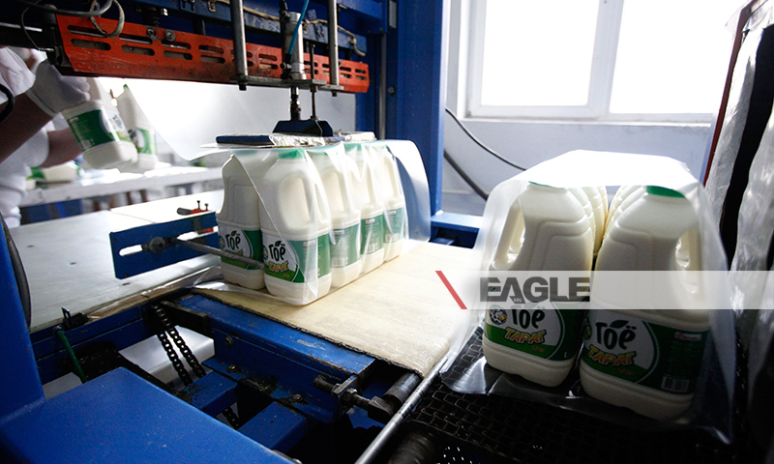

identifier
3b03365f-eda1-4f6a-9718-577a0d0ebbce

creator

type
Image

coverage
Mongolia

description
Goyo yogurt factory tour image published by Eagle.mn.

publisher

source

rights

subject
Mongolia
dairy
nationalism
social media

date
2014

language
Vitafit factory tour image - Vitafit factory tour image - 1km2j3had7jna91f6vf25n38j6 l

format
image/jpeg

original filename
1km2j3had7jna91f6vf25n38j6_l.jpg

extent
356.1 KiB
800x480 px

modified
2014-03-24 18:29:24

