Caroline Humphrey Mongolia Super8 film no. 11
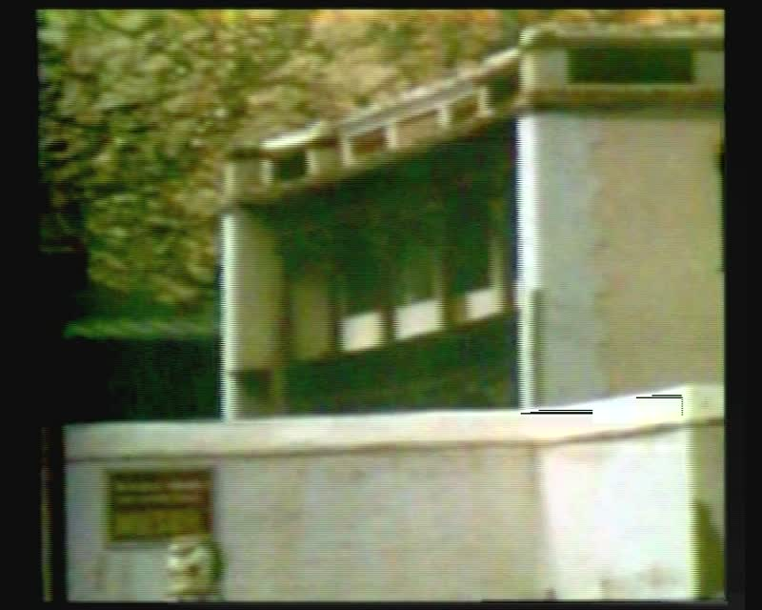

identifier
3bc5713c-662e-44aa-b575-4afbe84b759a

creator
Humphrey, Caroline

type
Moving Image

coverage
Arkhangai aimag
Mongolia

description
Tsetserleg (Arkhangai aimag). Park and monument in the town square; Tsetserleg Museum; apartment buildings and ger district.

publisher
MIASU

source
Digitized from a VCR transfer tape held at the Mongolia and Inner Asia Studies Unit, University of Cambridge

rights
Copyright Caroline Humphrey

subject
aimag centres

date
ca. 1970s

language
None

original filename
humphrey-super8-mongolia-11.mp4

extent
1014.9 MiB
215.915000

format
video/mp4

modified
2017-06-18 10:22:09

alternate url
https://archive.org/embed/3bc5713c-662e-44aa-b575-4afbe84b759a

