List of early Western explorers and travellers in Inner Asia
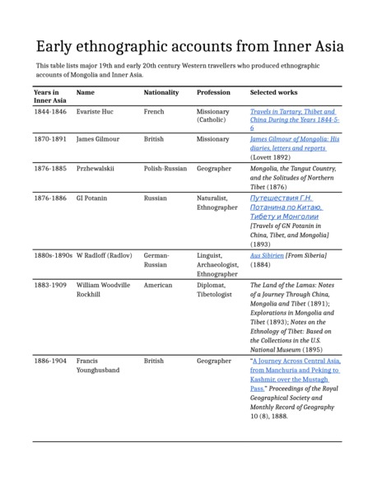

identifier
3c9d4c00-5e5a-4ef6-91ba-e222aa712a48

creator
Thrift, Eric

type
Text

coverage
Inner Asia

description
Table listing principal Western explorers who investigated the society and culture of Inner Asia in the late 19th and early 20th centuries.

publisher

source

rights

subject
expeditions
explorers

date
2017

language
English

format
application/zip

modified
2017-12-25 11:28:17

original filename
Inner-Asia-early-explorers.docx

extent
9.8 KiB

