Central Asia from Peking to Yarkand and Kashmir via the Mustagh Pass: Illustrating the journeys of Captain F. E. Younghusband, Kings Dragoon Guards
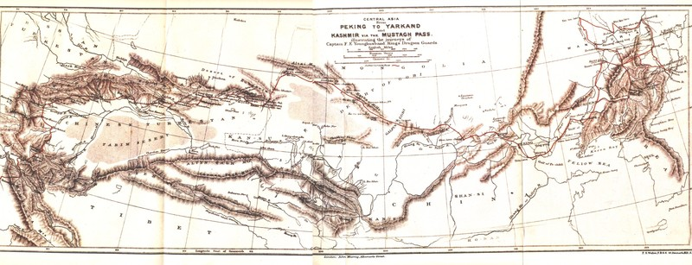

identifier
3d5e23f5-2c12-4f9f-a769-aa865eaadea9

creator
Murray, John

type
Image

coverage
PRC

description
A map showing the route of Frank E Younghusband on his trip from Beijing to Kashmir.

publisher

source
<https://commons.wikimedia.org/wiki/File:Younghusband_PekingToYarkand_Map.jpg>
The Heart of a Continent, A narrative of travels in Manchuria, across the Gobie Desart, Through the Himalayas, the Pamirs, And Chitral, 1884 - 1894.

rights
Public domain

subject
expeditions
maps

date

language
English

format
image/jpeg

modified
2017-10-09 12:12:35

original filename
Younghusband_PekingToYarkand_Map.jpg

extent
660.1 KiB
2346x899 px

