Building a well at Khamar Monastery
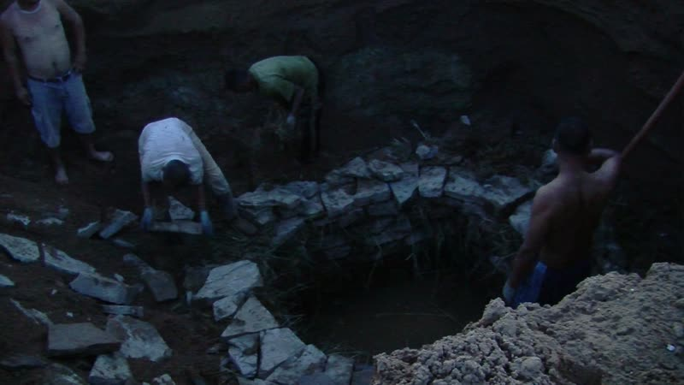

identifier
4147b0b5-1bfc-4ac4-8df1-1f533d3349e7

creator
Thrift, Eric

type
Moving Image

coverage
Mongolia

description
This series of recordings documents a sequence of activities over two days, in which a well is being reconstructed. The main well at Khamar Monstery, used by the monks' families and also for watering livestock, has caved in during a recent storm, and is now being rebuilt by the monks and families. At the beginning of this sequence the builders have had the ground dug out from one side by an excavator from the road construction crew working at the Monastery, and are rebuilding the well interior with large rocks brought from a quarry nearby. They fill the spaces between the rocks with dry brush. The water level in the new well is being kept down by two diesel pumps.

publisher

source

rights

subject
Pastoralism Videos
Building Well
Dornogovi-Khamar Monastery

date
2012-08-02-3

language

format
inode/directory

modified
2018-03-02 09:37:44

original filename
PastoralismVideos--2012-08-02-3--BuildingWell--Dornogovi-KhamarMonastery.vclips

table of contents
time | clip | description
0:00:00 | 300G0074 01 | Monks and others at Khamar Monastery building the well.
0:13:53 | 300G0074 02 | Monks and others at Khamar Monastery continue building the well.
0:26:13 | 300G0075 01 | Monks and others at Khamar Monastery continue building the well.
0:40:06 | 300G0075 02 | Monks and others at Khamar Monastery continue building the well.
0:54:00 | 300G0075 03 | Monks and others at Khamar Monastery continue building the well. A front-end loader from the road crew is summoned to backfill the dug-out section of the well up to the level that has been rebuilt.
1:07:54 | 300G0075 04 | Monks and others at Khamar Monastery continue building the well. The road crew front-end loader continues backfilling.
1:17:44 | 300G0075 05 | Monks and others at Khamar Monastery continue building the well. The road crew front-end loader continues backfilling.
1:31:38 | 300G0075 06 | The front-end loader finishes backfilling the rebuilt part of the well. Monks fill its bucket with stones, then have these dumped onto the dirt next to where the well is being rebuilt. The workers inside the well continue laying stones.
1:45:32 | 300G0075 07 | Monks and others at Khamar Monastery continue building the well. By now it is getting quite dark, and everyone is ready to call off the work for the night.
1:48:51 | 300G0076 01 | The next morning. The well has filled with water overnight. The Monastery maintenance staff are trying to get a diesel pump to start, so as to pump the water out of the well and resume work. Finally the pump starts.
2:02:44 | 300G0076 02 | Pumping water out of the well. Workers at the edge of the well prepare brush.
2:07:19 | 300G0077 01 | Some time later, the incomplete part of the new well has been pumped dry. Tsolmon, Togtokh, and Idermonkh dig stones out of the mud. One of the drivers of the vans taking pilgrims from Sainshand to the Monastery uses the hose from the pump connected to the well to wash his vehicle. Tsolmon makes a mud dam to prevent discharged water from flowing back into the well.
2:21:12 | 300G0077 02 | The workers gather stones and prepare brush. Togtokh descends into the sell to resume the construction.
2:35:06 | 300G0077 03 | Rebuilding the well continues.
2:49:00 | 300G0077 04 | Rebuilding the well continues. A herd of camels arrives.
2:59:13 | 300G0078 01 | Rebuilding the well continues.The camels drink from the water discharged from the well.
3:13:06 | 300G0078 02 | Rebuilding the well continues.
3:16:12 | 300G0078 03 | Rebuilding the well continues.

