David Sneath - photographs from Xingmeng, Yunnan - No. 02
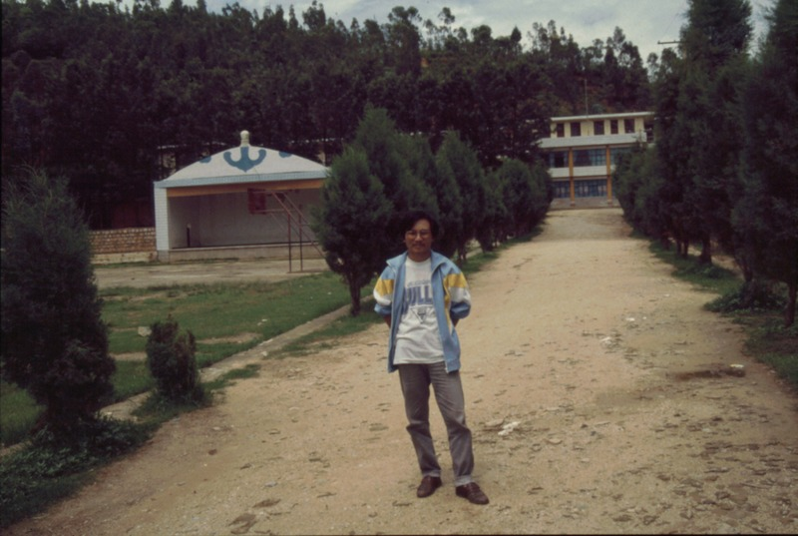

identifier
4347541e-09b2-4f78-9394-8397e5b0df72

creator
Sneath, David

type
Image

coverage
PRC
Yunnan

description
Batu, the Mongolian language teacher at Xingmeng school. On his right is one of the school buildings, incorporating a ‘Mongolian’ architectural motif.

publisher

source
Digitized from a 35mm slide provided by the author.

rights

subject

date
1997

language

format
image/tiff

contributor

original filename
David Sneath - photographs from Xingmeng, Yunnan - No. 02.tif

relation

extent
42.6MiB
4704x3168 px

public

