Sven Hedin’s expedition through the Gobi
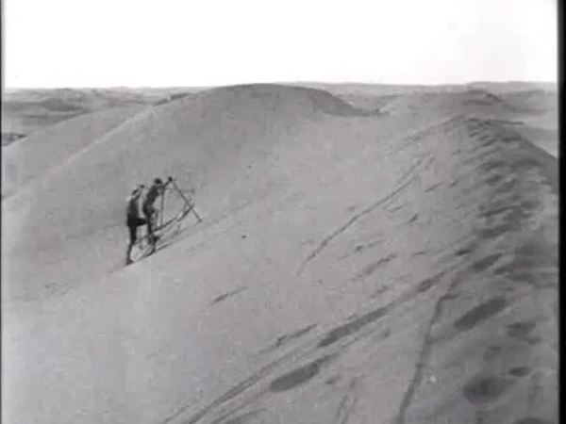

identifier
437930a5-9b96-4a4b-acdd-4d4df0037d35

creator
Hedin, Sven

type
Moving Image

coverage
Gobi
Inner Mongolia
PRC
Xinjiang

description
A silent documentary made in 1928 of Swedish explore Sven Hedin's expedition through the Gobi desert of Inner Mongolia and Xinjiang. Towns visited include Baotou (Paotou), Hami (Kumul) and Urumchi (Urumqi). At the very end of the film Sven Hedin meets Xinjiang's warlord governor Yang Zengxin (who was assassinated a few months later).

publisher
Swedish Mission Project

source
<https://archive.org/details/swedish-mission-project>

rights
public domain

subject
Gobi
ethnographic film
expeditions
explorers

date
1928

language
English

original filename
sven-hedin-1928-expedition-through-the-gobi.avi

extent
1.8 GiB
6076.107755

remote embed url
https://archive.org/embed/swedish-mission-project/sven-hedin-1928-expedition-through-the-gobi.avi

format
video/x-msvideo

modified
2017-10-10 16:26:14

