Хортой сүү Монголд орж ирчихсэн юм биш үү
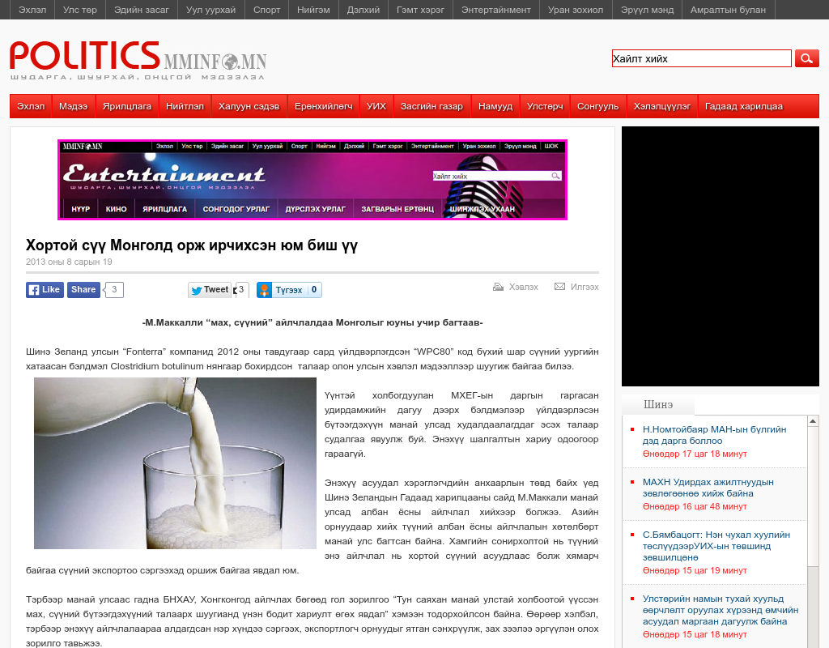

identifier
440574eb-c6ba-4760-9bc4-3dcc72be34a9

creator

type
Text

coverage
Mongolia

description

publisher

source
http://www.mminfo.mn/content/48048.shtml?alias=politics

rights

subject
Mongolia
dairy
nationalism
social media

date
9 Jun 2014 20:56:34

language
Mongolian

format
text/plain

modified
2018-01-11 14:12:43

original filename
mminfo.mn.Khortoi_suu.url

extent
55.0 B

