Vitafit factory tour image - 6p4626qoi554q9tl2rjdicqsip l
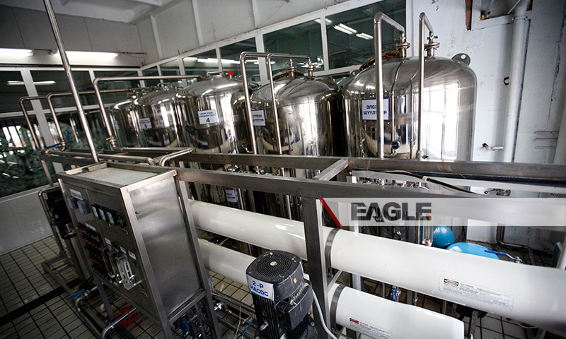

identifier
44a96f53-4960-4944-8d38-fa54fb8c3294

creator

type
Image

coverage
Mongolia

description
Goyo yogurt factory tour image published by Eagle.mn.

publisher

source

rights

subject
Mongolia
dairy
nationalism
social media

date
2014

language
Vitafit factory tour image - Vitafit factory tour image - 6p4626qoi554q9tl2rjdicqsip l

format
image/jpeg

original filename
6p4626qoi554q9tl2rjdicqsip_l.jpg

extent
404.3 KiB
800x480 px

modified
2014-03-24 18:29:12

