Sneath-migration-zones-sketch-map
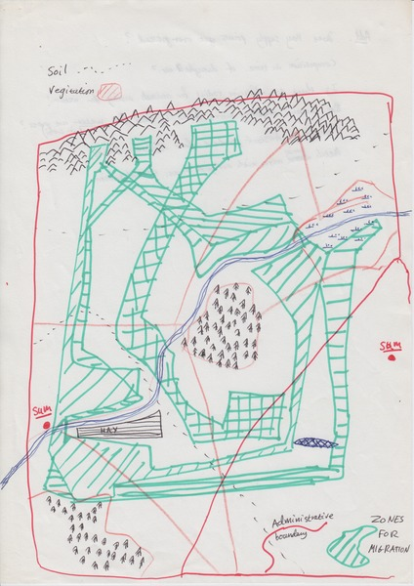

identifier
45feba40-ccd3-46b5-b887-df146c144de7

creator
Sneath, David

type
Image

coverage

description

publisher

source
Scanned from an original document held in the archives of the Mongolia and Inner Asia Studies Unit, University of Cambridge.

rights

subject
maps

date
ca. 1992

language

original filename
Sneath-migration-zones-sketch-map.png

relation

extent
14.8 MiB
2480x3507 px

contributor

format
image/png

modified
2017-05-25 10:33:18

