Photograph of Handgate, Xinjiang by Tsui Yen Hu, 1993, No. 44
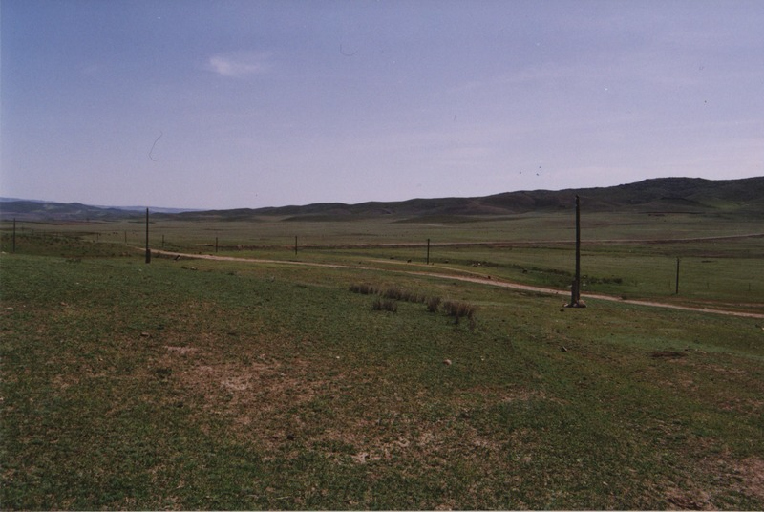

identifier
46a14582-19c1-4024-a5ab-f88cac17a941

creator
Tsui Yen Hu

type
Image

coverage
Altai district
Handgate
PRC
Xinjiang

description
Dund-bulag, Handgate. Spring pasture, with some damage.

publisher

source
Scanned from colour print held in the archives of the University of Cambridge MacArthur Project "Environmental and Cultural Conservation in Inner Asia", Mongolia and Inner Asia Studies Unit.

rights

subject
pastoralism

date
1993

language

format
image/png

contributor

original filename
TsuiYenHu-Handgate-1993-44.png

relation

extent
1777x1191 px
3.3 MiB

