Photograph from Inner Mongolia, No. 12
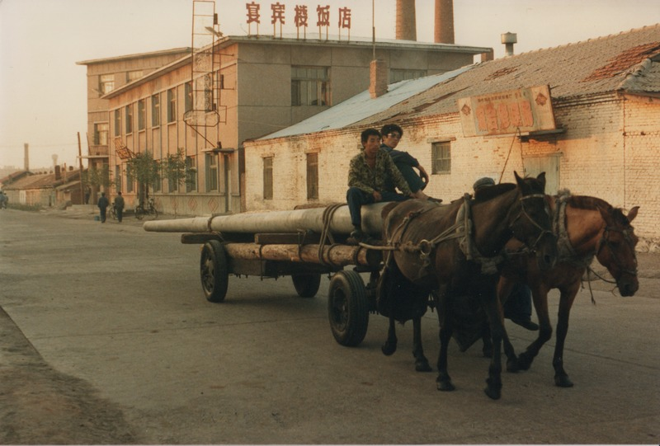

identifier
48198965-18bf-4720-b788-5ef38d15ccda

creator
Sneath, David

type
Image

coverage
Inner Mongolia
PRC

description
Transporting poles by horse-cart.

publisher

source
Scanned from a photographic print held in the archives of the Mongolia and Inner Asia Studies Unit, University of Cambridge.

rights

subject
horse-carts

date
ca. 1988

language

original filename
sneath-inner-mongolia-1980s.png_12.png

relation

extent
3.1 MiB
1747x1182 px

contributor

format
image/png

modified
2017-05-25 11:05:04

